Install and Configure SQL Server 2008 Express
SQL 2008 Express is available free from Microsoft. It is a replacement for MSDE and SQL 2005 which will perform much better than its predecessors. SQL 2008 has no workload throttling like MSDE does and it supports up to 2 CPUs and 2GB RAM, where MSDE only supports 1 CPU and 1GB RAM.
If you are using MSDE and are considering managing more clients than you currently are, or are having problems with your Deployment Server or Notification Server running slowly even after optimizing your configuration, you will want to install SQL Server 2008 instead of MSDE.
SQL 2008 Express supports servicing SQL over your network and so it can be used for Deployment Server and Notification Server as long as you don't have enough clients that you will need more than 2GB RAM. However, network is not enabled by default, so there is some configuration required to get SQL Server 2008 Express to work correctly.
This article will guide you through the process of installing and configuring SQL Server 2008 Express so that you can use it with Deployment Server or Notification Server.

Download SQL Server 2008 Express
First, you will need to download SQL Server 2008 Express. You have two options to download. You can either download SQL Server 2008 Express without any management tools (61 MB) fromhttp://go.microsoft.com/?linkid=9314315 or you can download SQL Server 2008 Express with management tools (219 MB) from http://go.microsoft.com/?linkid=9394725
I recommend installing "SQL Server 2008 Express with Tools", it is worth the extra 150 MB to be able to troubleshoot your SQL Server if anything ever goes wrong.

Install SQL Server 2008 Express
SQL Server 2008 Express requires .NET Framework 3.5 SP1, if your server does not have .NET Framework 3.5 SP1 you will need to download .NET Framework 3.5 SP1 and install it on your server. You can download .NET Framework 3.5 SP1 from http://go.microsoft.com/fwlink/?LinkId=120550
SQL Server 2008 Express requires Windows Installer 4.5, if your server does not have Windows Installer 4.5 you will need to download Windows Installer 4.5 and install it on your server. You can download Windows Installer 4.5 from http://go.microsoft.com/fwlink/?LinkId=123422
SQL Server 2008 Express requires Windows PowerShell 1.0, if your server does not have Windows PowerShell 1.0 you will need to download Windows PowerShell 1.0 and install it on your server. You can download Windows PowerShell 1.0 from http://go.microsoft.com/fwlink/?LinkId=120552
When you are ready to install SQL 2008 Express, follow these steps:
- Run SQLEXPRWT_x86_ENU.EXE (or SQLEXPRWT_x64_ENU) to install SQL 2008 Express.
- At the "SQL Server Installation Center", choose "System Configuration Checker" to make sure you are ready to install SQL 2008 Express

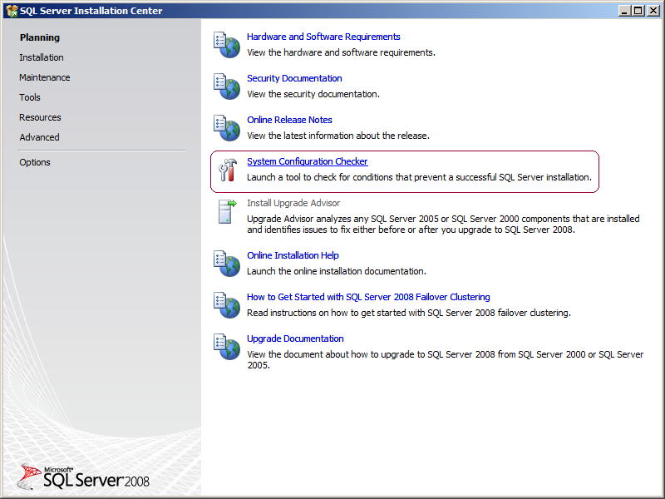
  - When the "System Configuration Checker" has validated that you are ready to install SQL 2008 Express, return to the "SQL Server Installation Center" and click on Installation

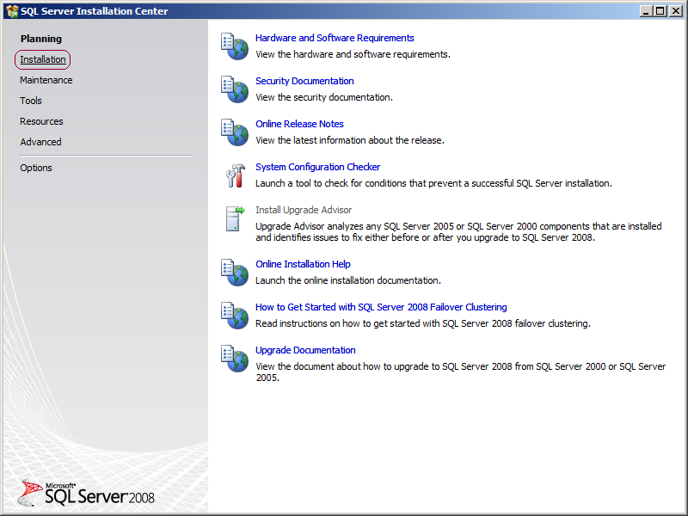
  - Select "New SQL Server stand-alone installation or add features to an existing installation"

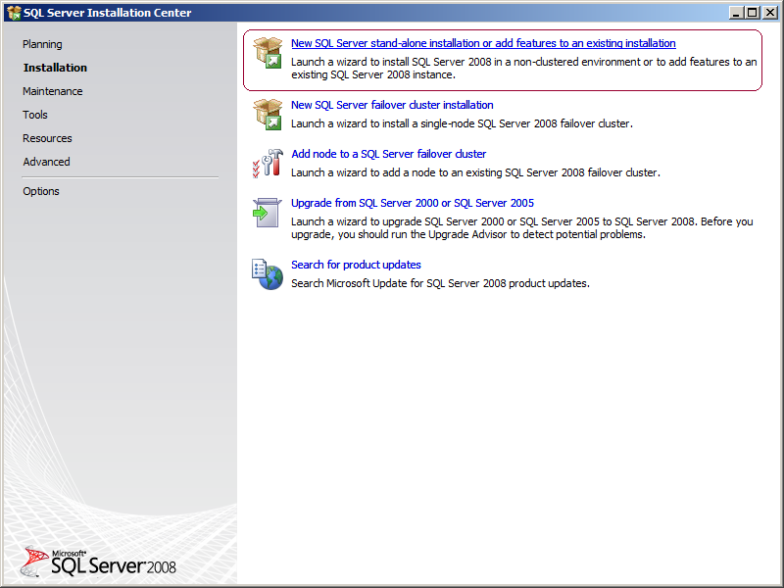
  - A setup support check will run. Make sure there are no errors or warnings, press OK.
  - The "SQL Server 2008" Setup will now appear, on the Product Key page, click Next.
  - Check the box "I accept the license terms" and click Next.
  - Click "Install" to install the Setup Support Files.
  - When the Setup Support Files install is complete, click Next.
  - You will now be in the "Feature Selection" page. Select "Database Engine Services" and "Management Tools - Basic" and then click Next.
  - In the "Instance Configuration" page, specify MSSQLSERVER in both the "Named instance" and "Instance ID" fields, this will force SQL Server 2008 Express to install as the Default instance. If you want to install as a named instance, specify a name other than MSSQLSERVER

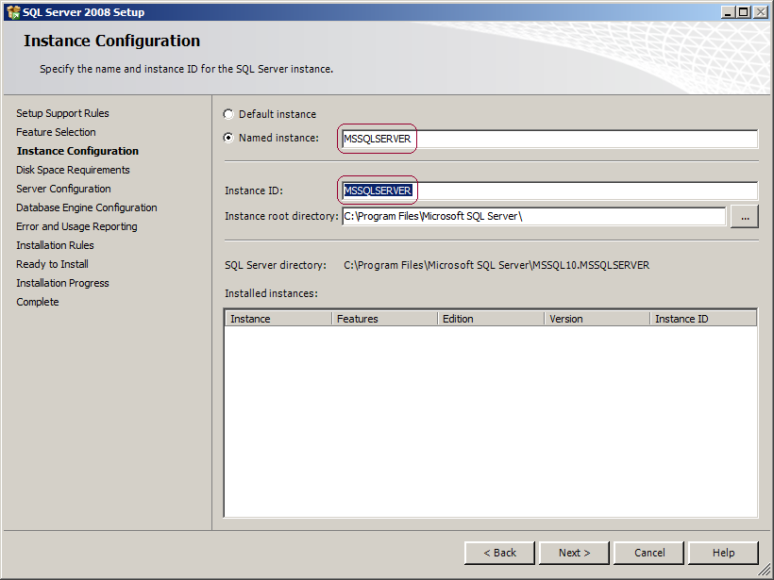

  - Click next twice.
  - You will now be in the "Server Configuration" page. Change the SQL Server Database Engine's Account Name to "NT AUTHORITY\SYSTEM" and SQL Server Browser's Startup Type to Automatic, then click Next.

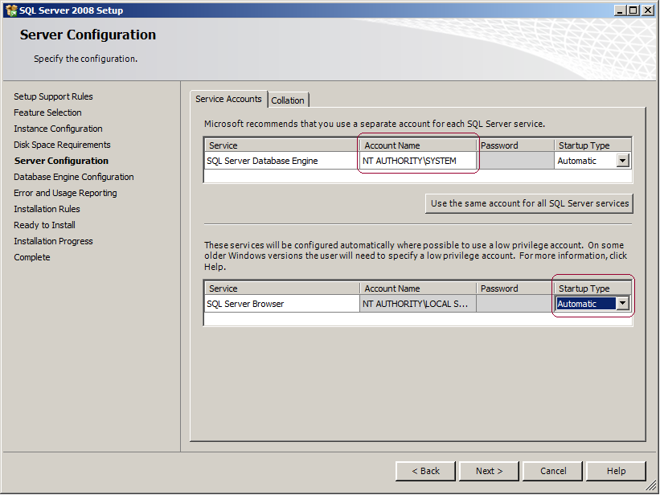
  - On the Database Engine Configuration page, you can either leave it configured to use Windows Authentication Mode only or Mixed Mode (SQL Server authentication and Windows authentication). I usually enable Mixed Mode so that if for some reason my security gets messed up I always have a backdoor account (the SA account). If you choose Mixed Mode, you will need to enter and confirm a password for the SA account.
  - Before you can continue, you will need to specify the group(s) that you want to have unrestricted access to SQL Server. Click "Add..." and select the group(s). I recommend that you at least add Administrators and the "Current User" (Service Account). When you are done here, click Next three times, and then click Install.
  - When the installer completes, click Next and then Close.

Enable TCP/IP
Now that SQL 2008 Express is installed, we need to configure the Network options that are disabled by default.
- In the Start Menu, open Programs > Microsoft SQL Server 2008 > Configuration Tools > SQL Server Surface Area Configuration
- In the Surface Area Configuration utility, click the link "SQL Server Configuration Manager"
- Expand "SQL Server Network Configuration" and select Protocols.
- Enable TCP/IP. If you need Named Pipes, then you can enable them here as well.
- Close the SQL Server Configuration Manager.

Add Firewall Exceptions
If you have a software firewall installed on your server, you will need to add exceptions for the SQL Server and SQL Browser services. If you are using Windows Firewall, do the following:
- In your Control Panel, open the Windows Firewall applet.
- Go to the Exceptions tab.
- Click Add Program
- Browse to and select "C:\Program Files\Microsoft SQL Server\MSSQL.10\MSSQL\Binn\sqlservr.exe"
- Click OK.
- Click Add Program
- Browse to and select "C:\Program Files\Microsoft SQL Server\90\Shared\sqlbrowser.exe"
- Click OK and then click OK again.
If you are using a third-party software firewall, you will need to follow their instructions to add exceptions to sqlservr.exe and sqlbrowser.exe.

Restart the Services or Reboot the Server
When you have completed all of these steps, you will need to restart the SQL Server and SQL Browser services to complete the process. If you still have problems, you may need to restart your server.

